**Build a Jenkins Pipeline (Pipeline Job) that Builds a sample Java Application and hosts it in Multiple EC2 Apache Tomcat Servers.**

Three new Ec2 instances were launched using AWS. Proper security groups were attached to the instances.

The instances were named as

Master

Server 1

Server 2

Apache tomcat was downloaded and installed in opt root directory

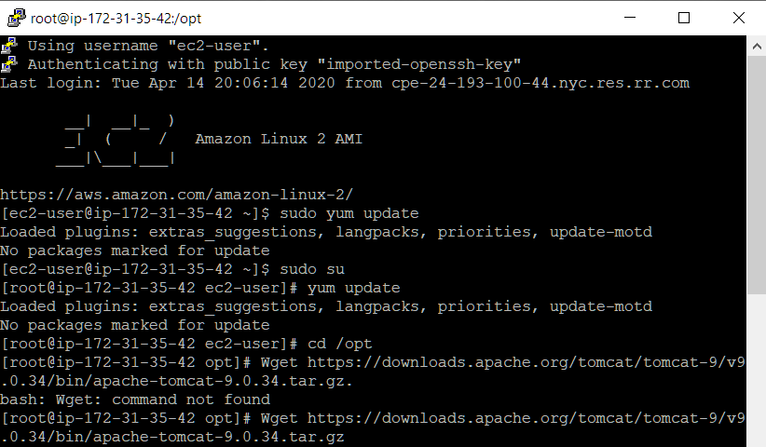

The file was unzipped and untared using tar -zvxf command

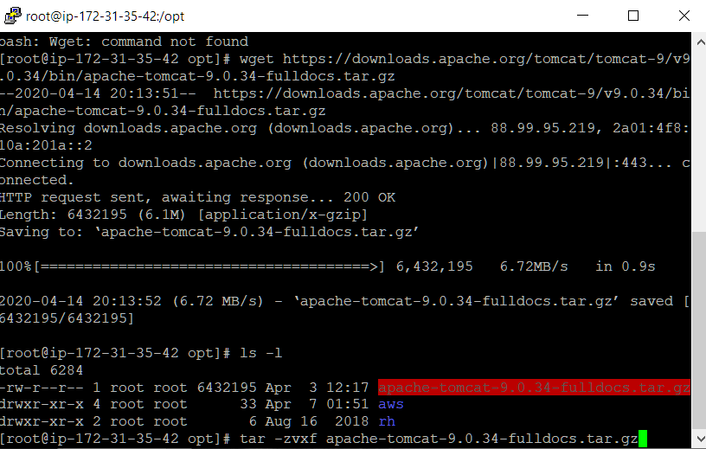

Tomcat was started in bin Bin directory using ./startup.sh command

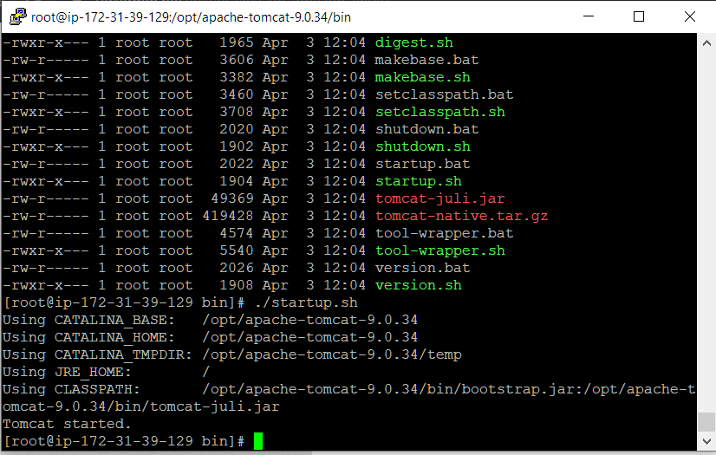

Tomcat servers on both the instances are up and running

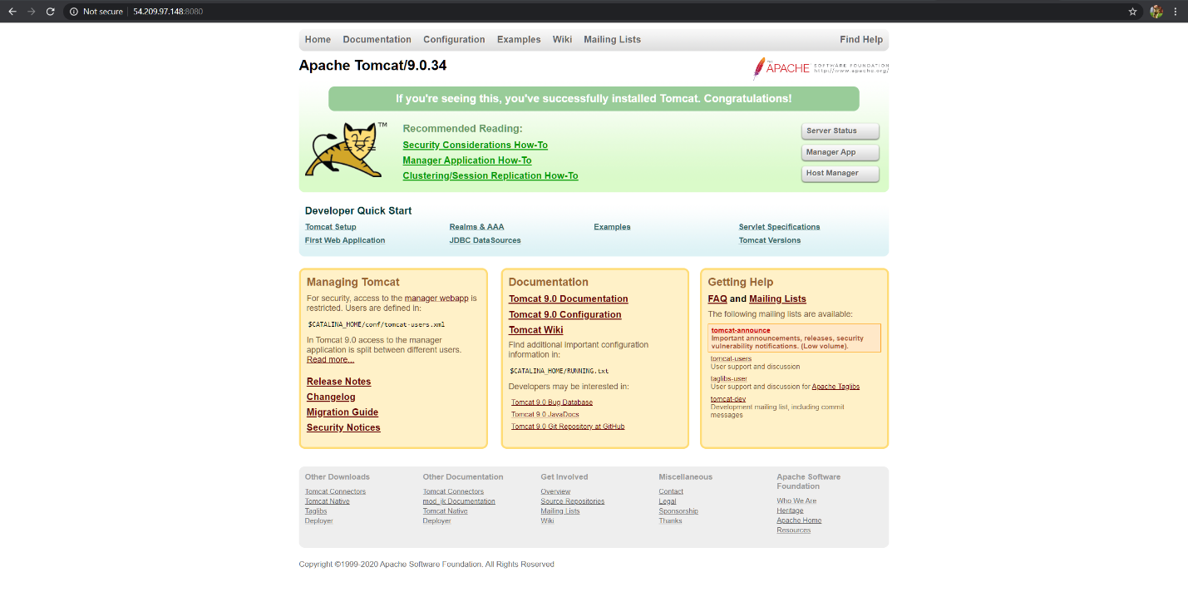

Jenkins was installed on Master Instance

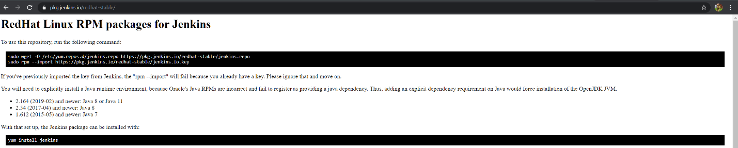

Jenkins service was started in root directory

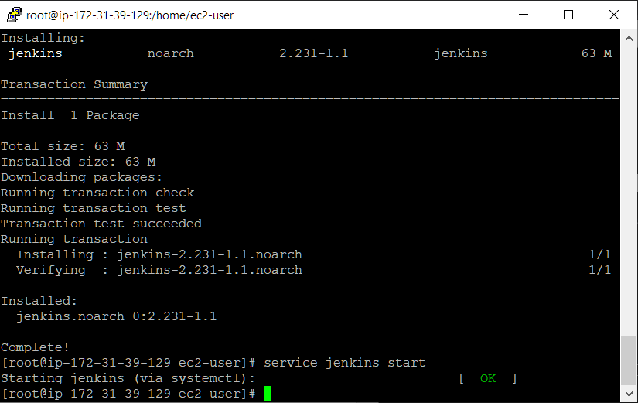

Maven was also installed also customized plugins in Jenkins were installed

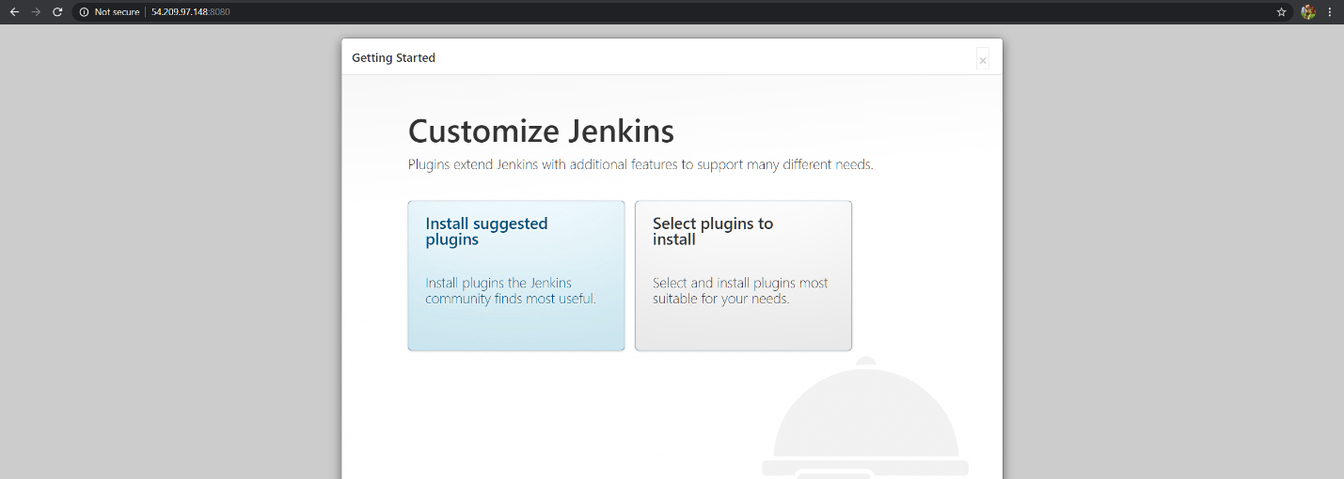

Proper build environments were made in Publish over SSH environment

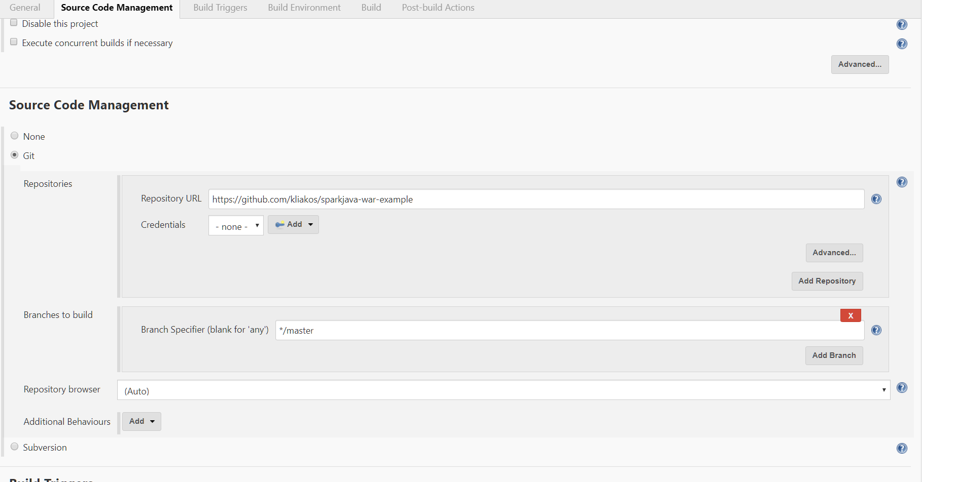

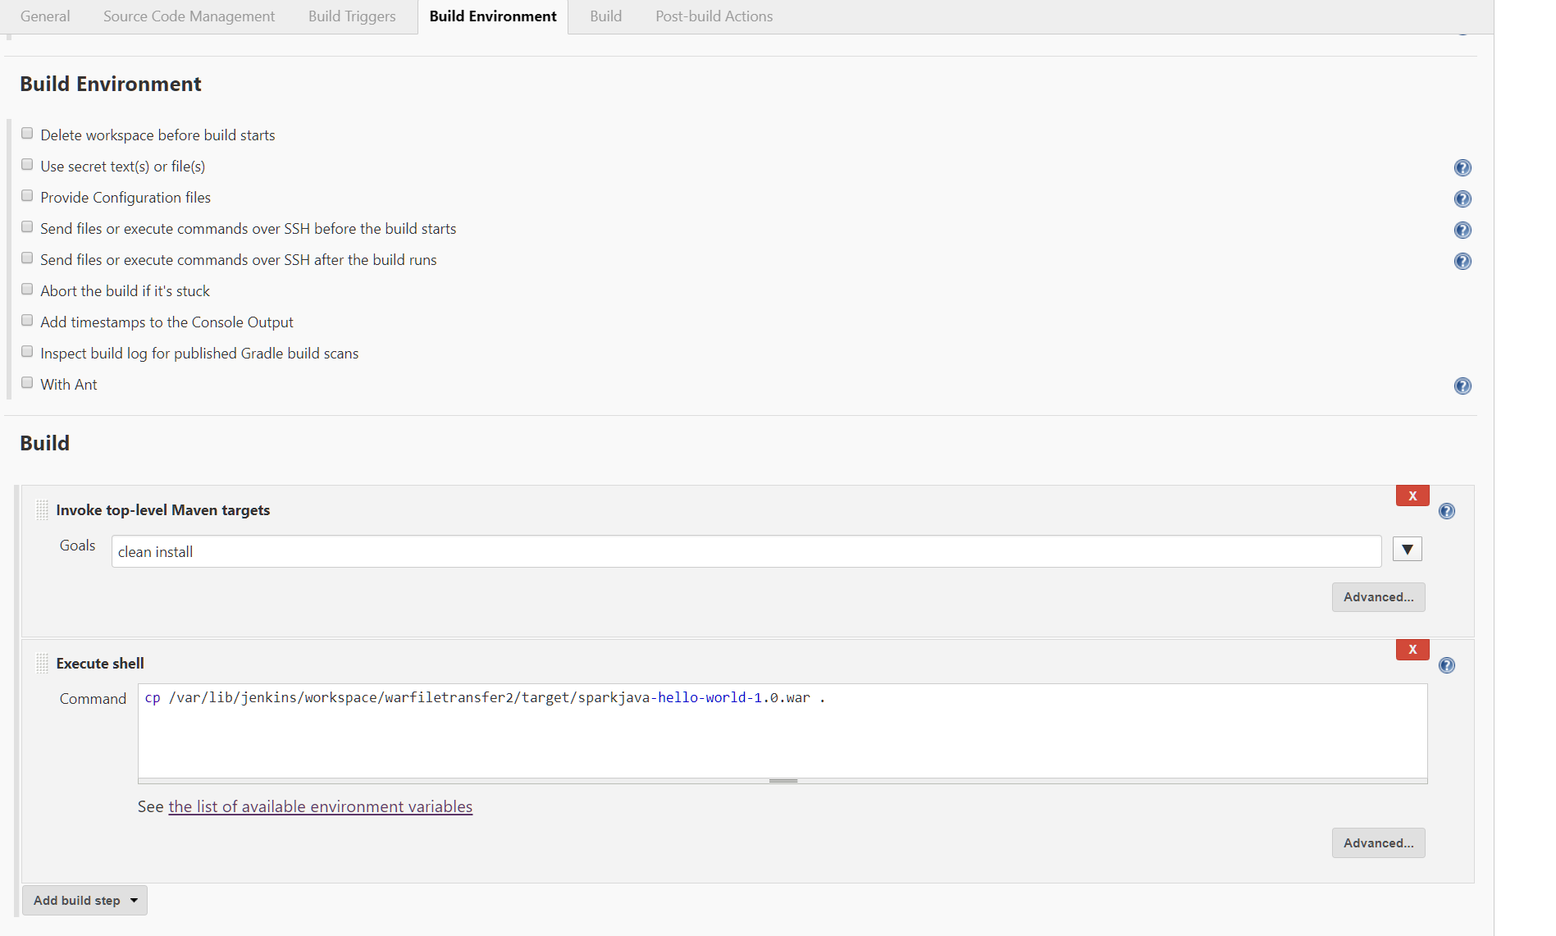

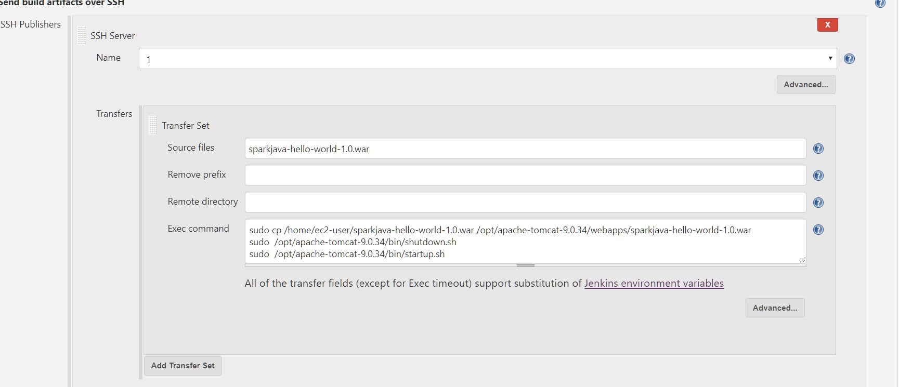

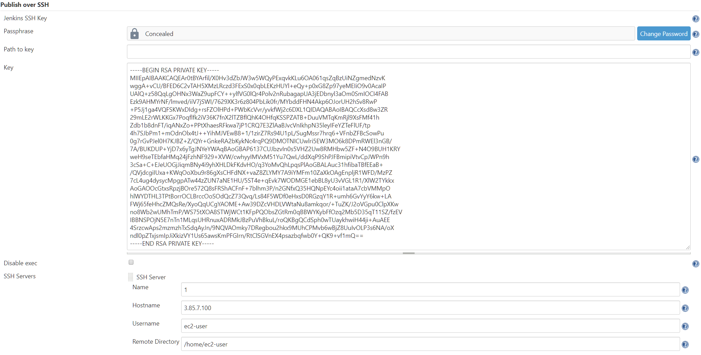

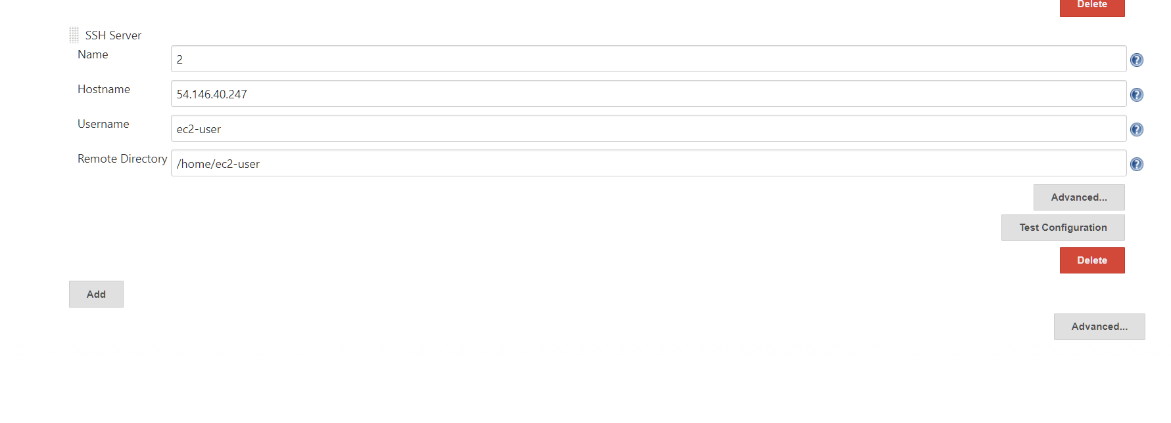

Pipeline was setup as well

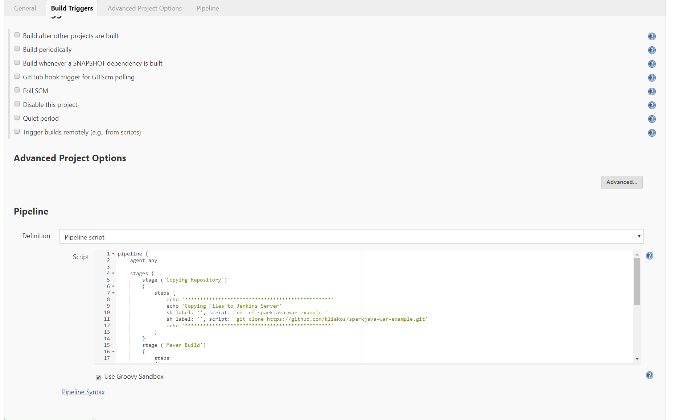

Files were copied to both the Tomcat servers

